***

Did not finish the following problems:

10)**Canonical Number**

6)**Boolean**

5)**Lower Bound**

***

**Homework 8:**

1)**Reductions**

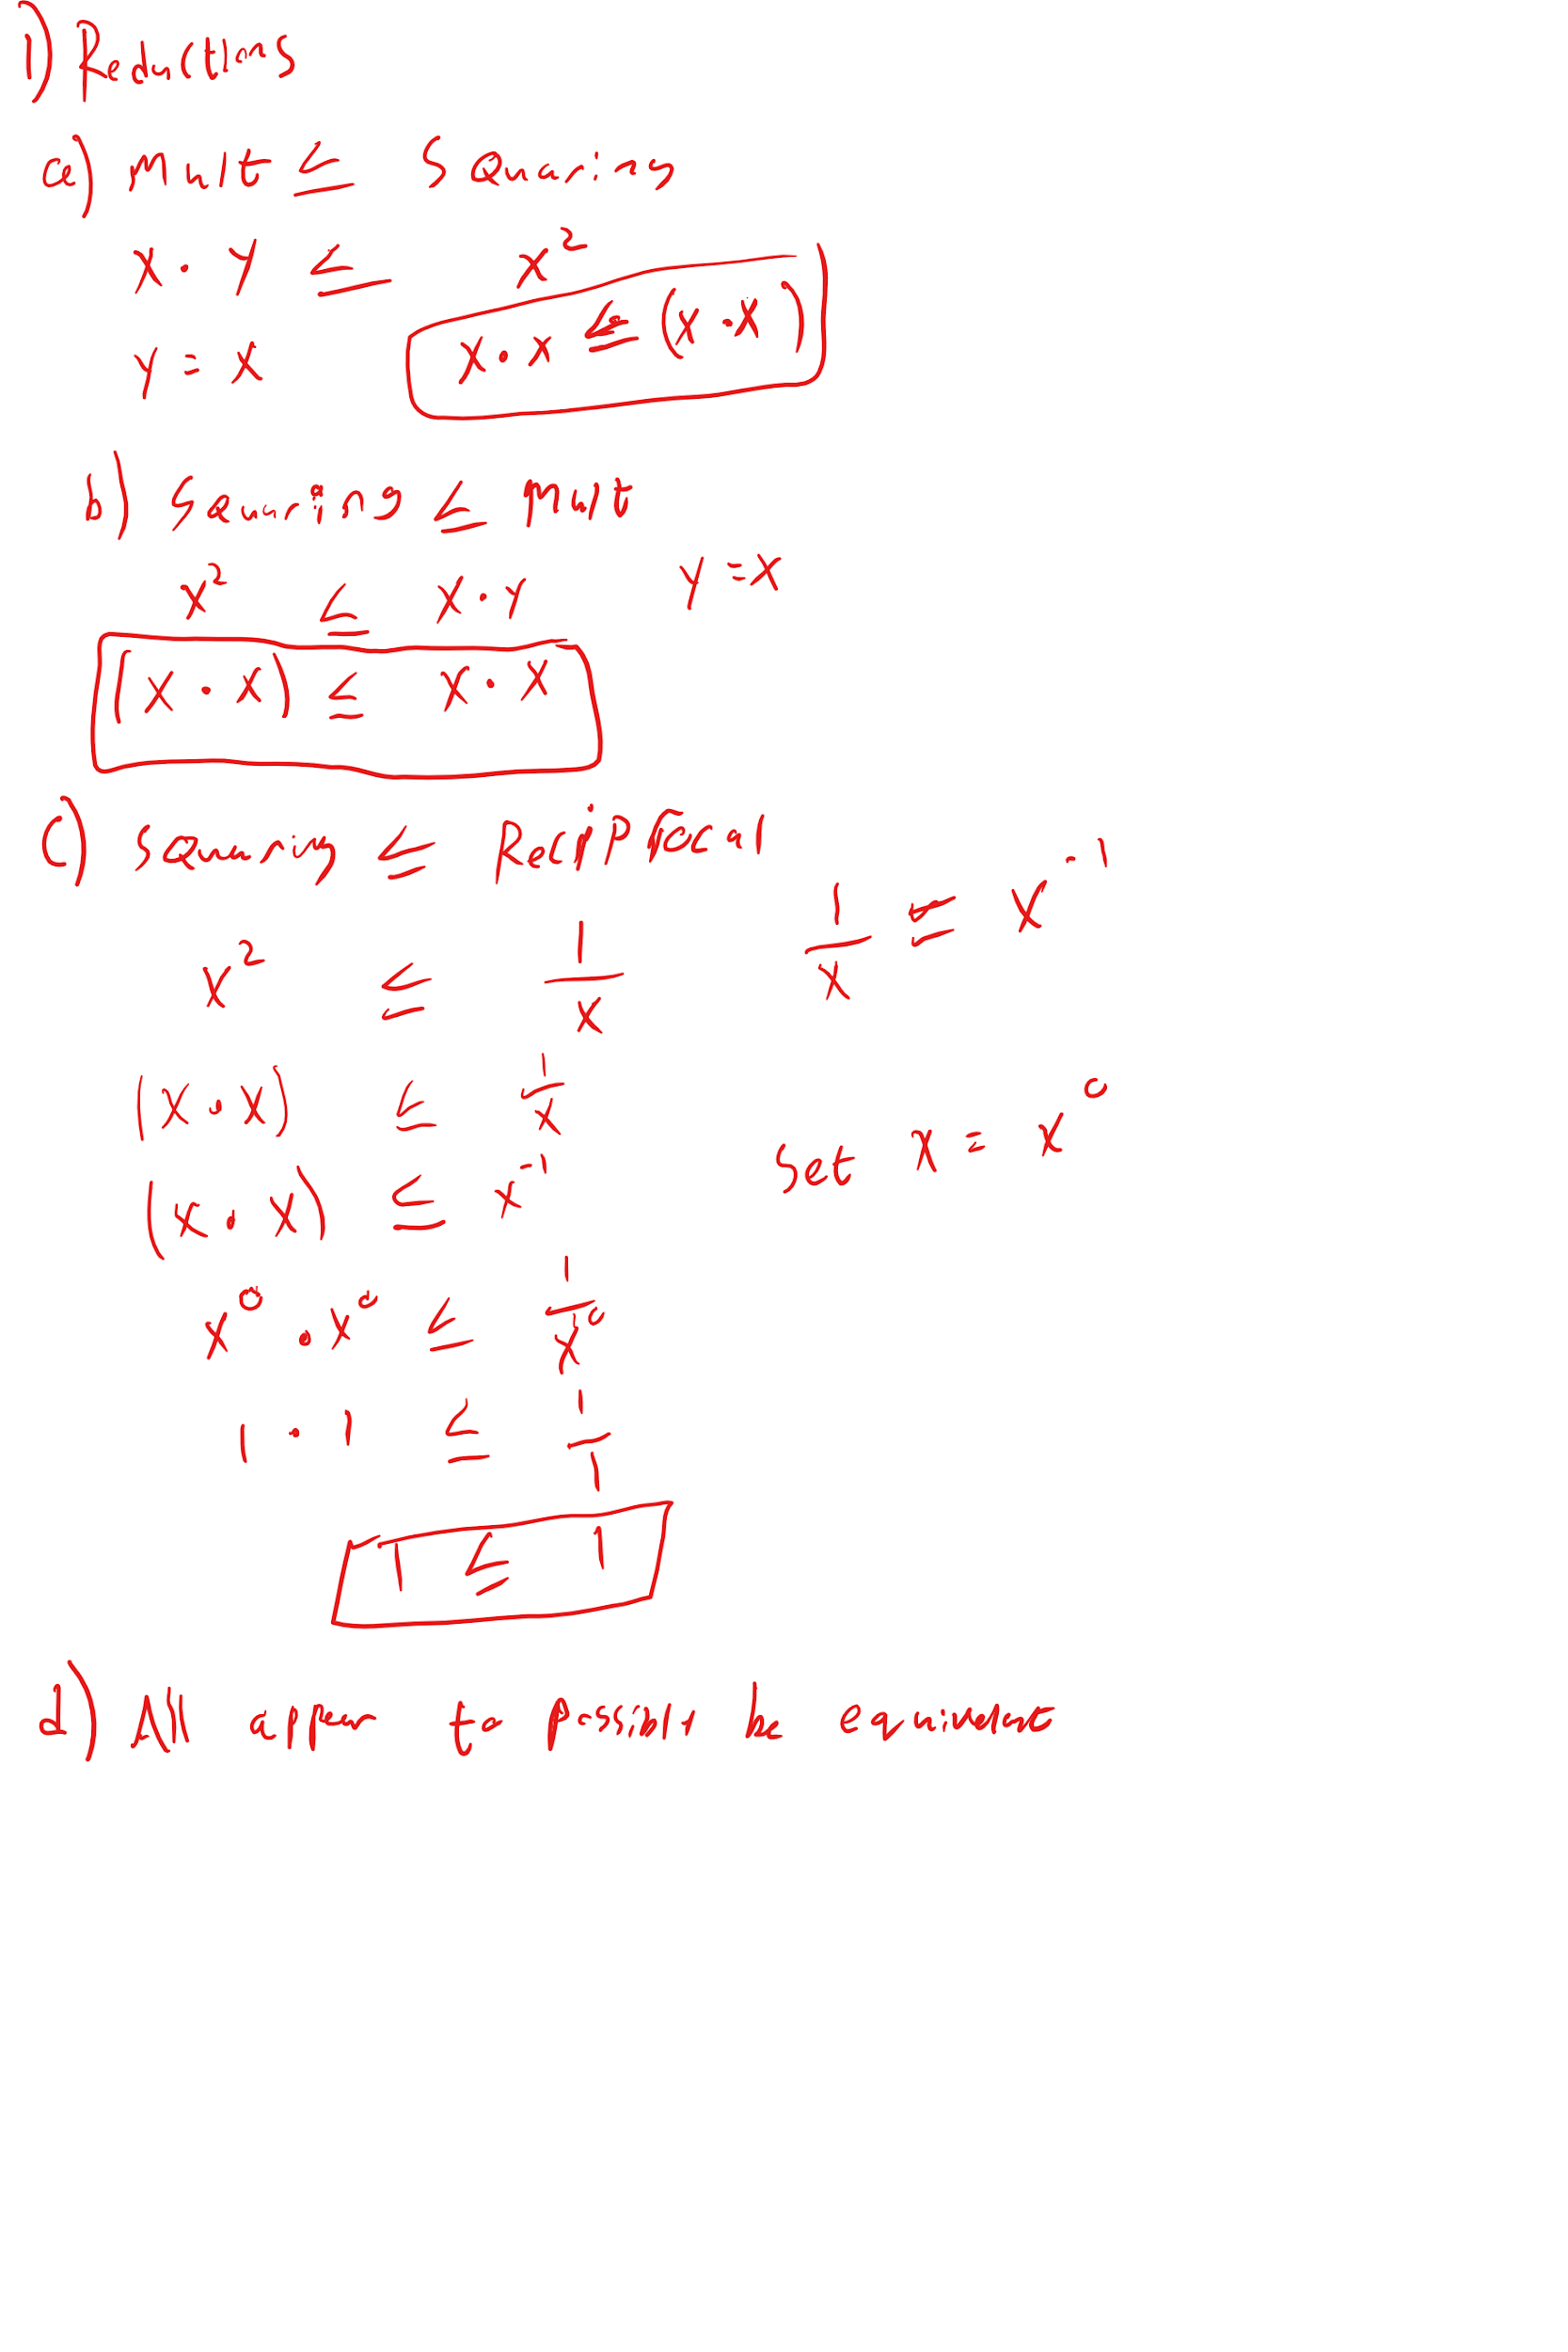

2)**Lucas Numbers**

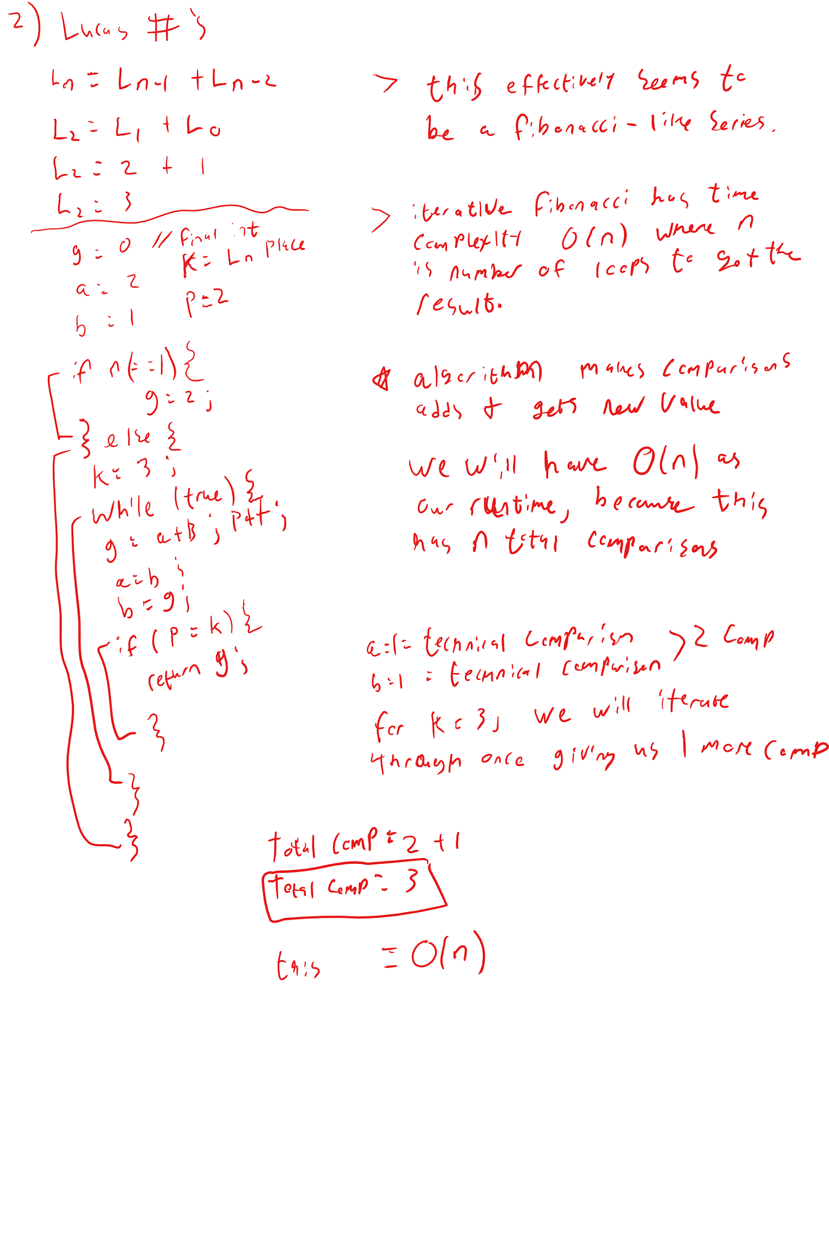

3)**Roots**

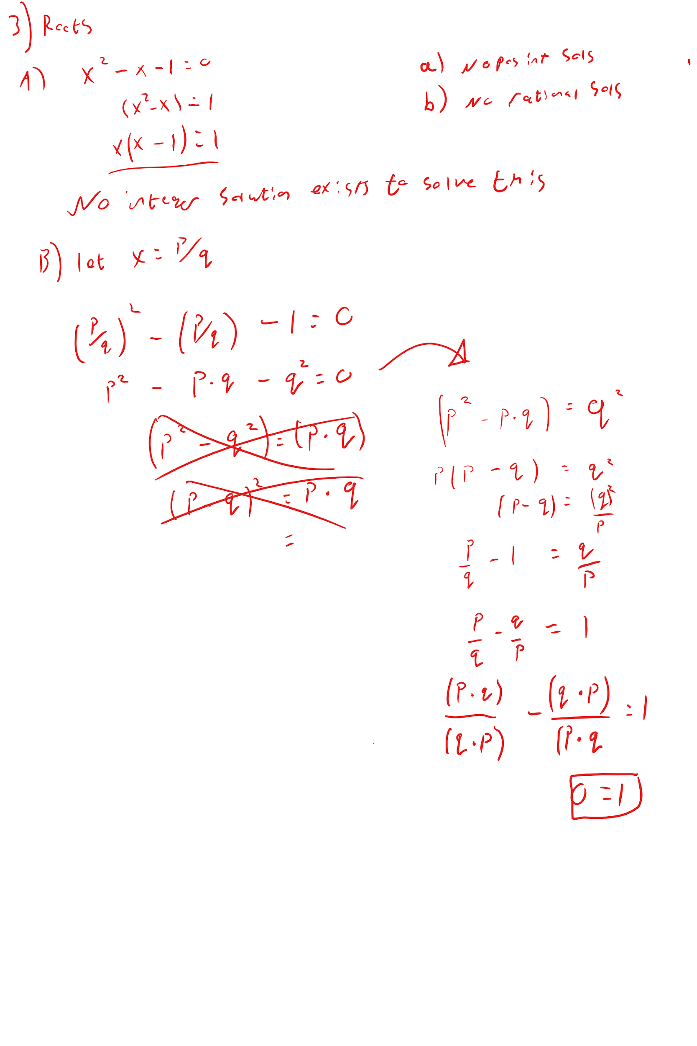

4)**Average Case**

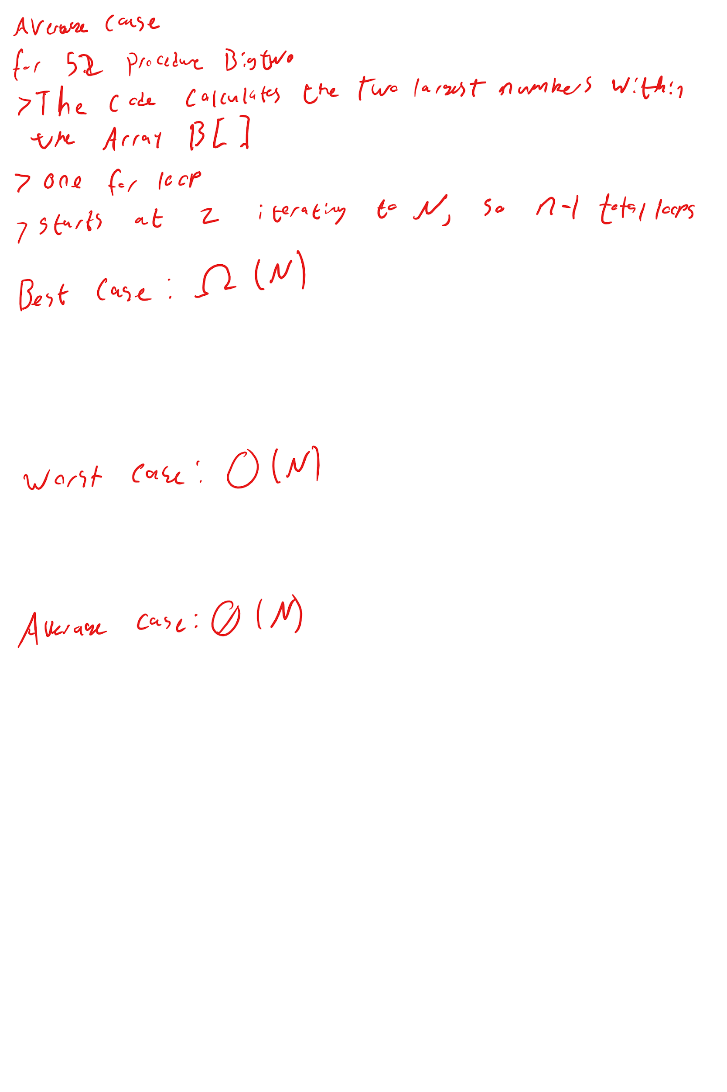

5)**Lower Bound**

**n/a**

6)**Boolean**

**n/a**

7)**Platonic Hamiltonian Circuits**

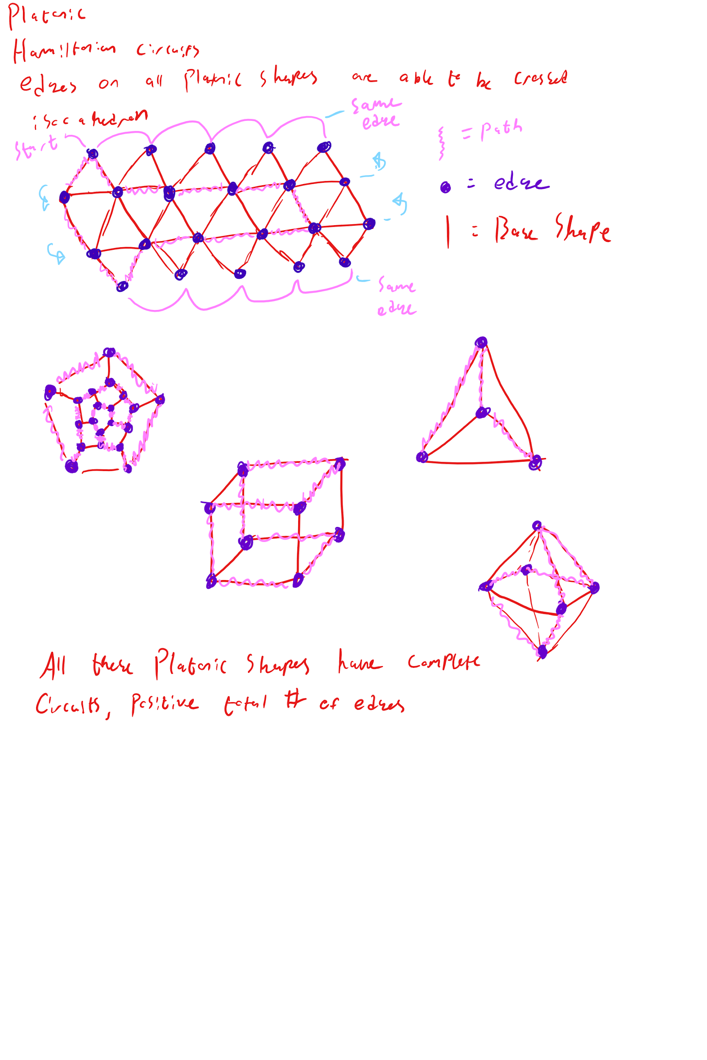

8)**s-t Hamiltonian Path**

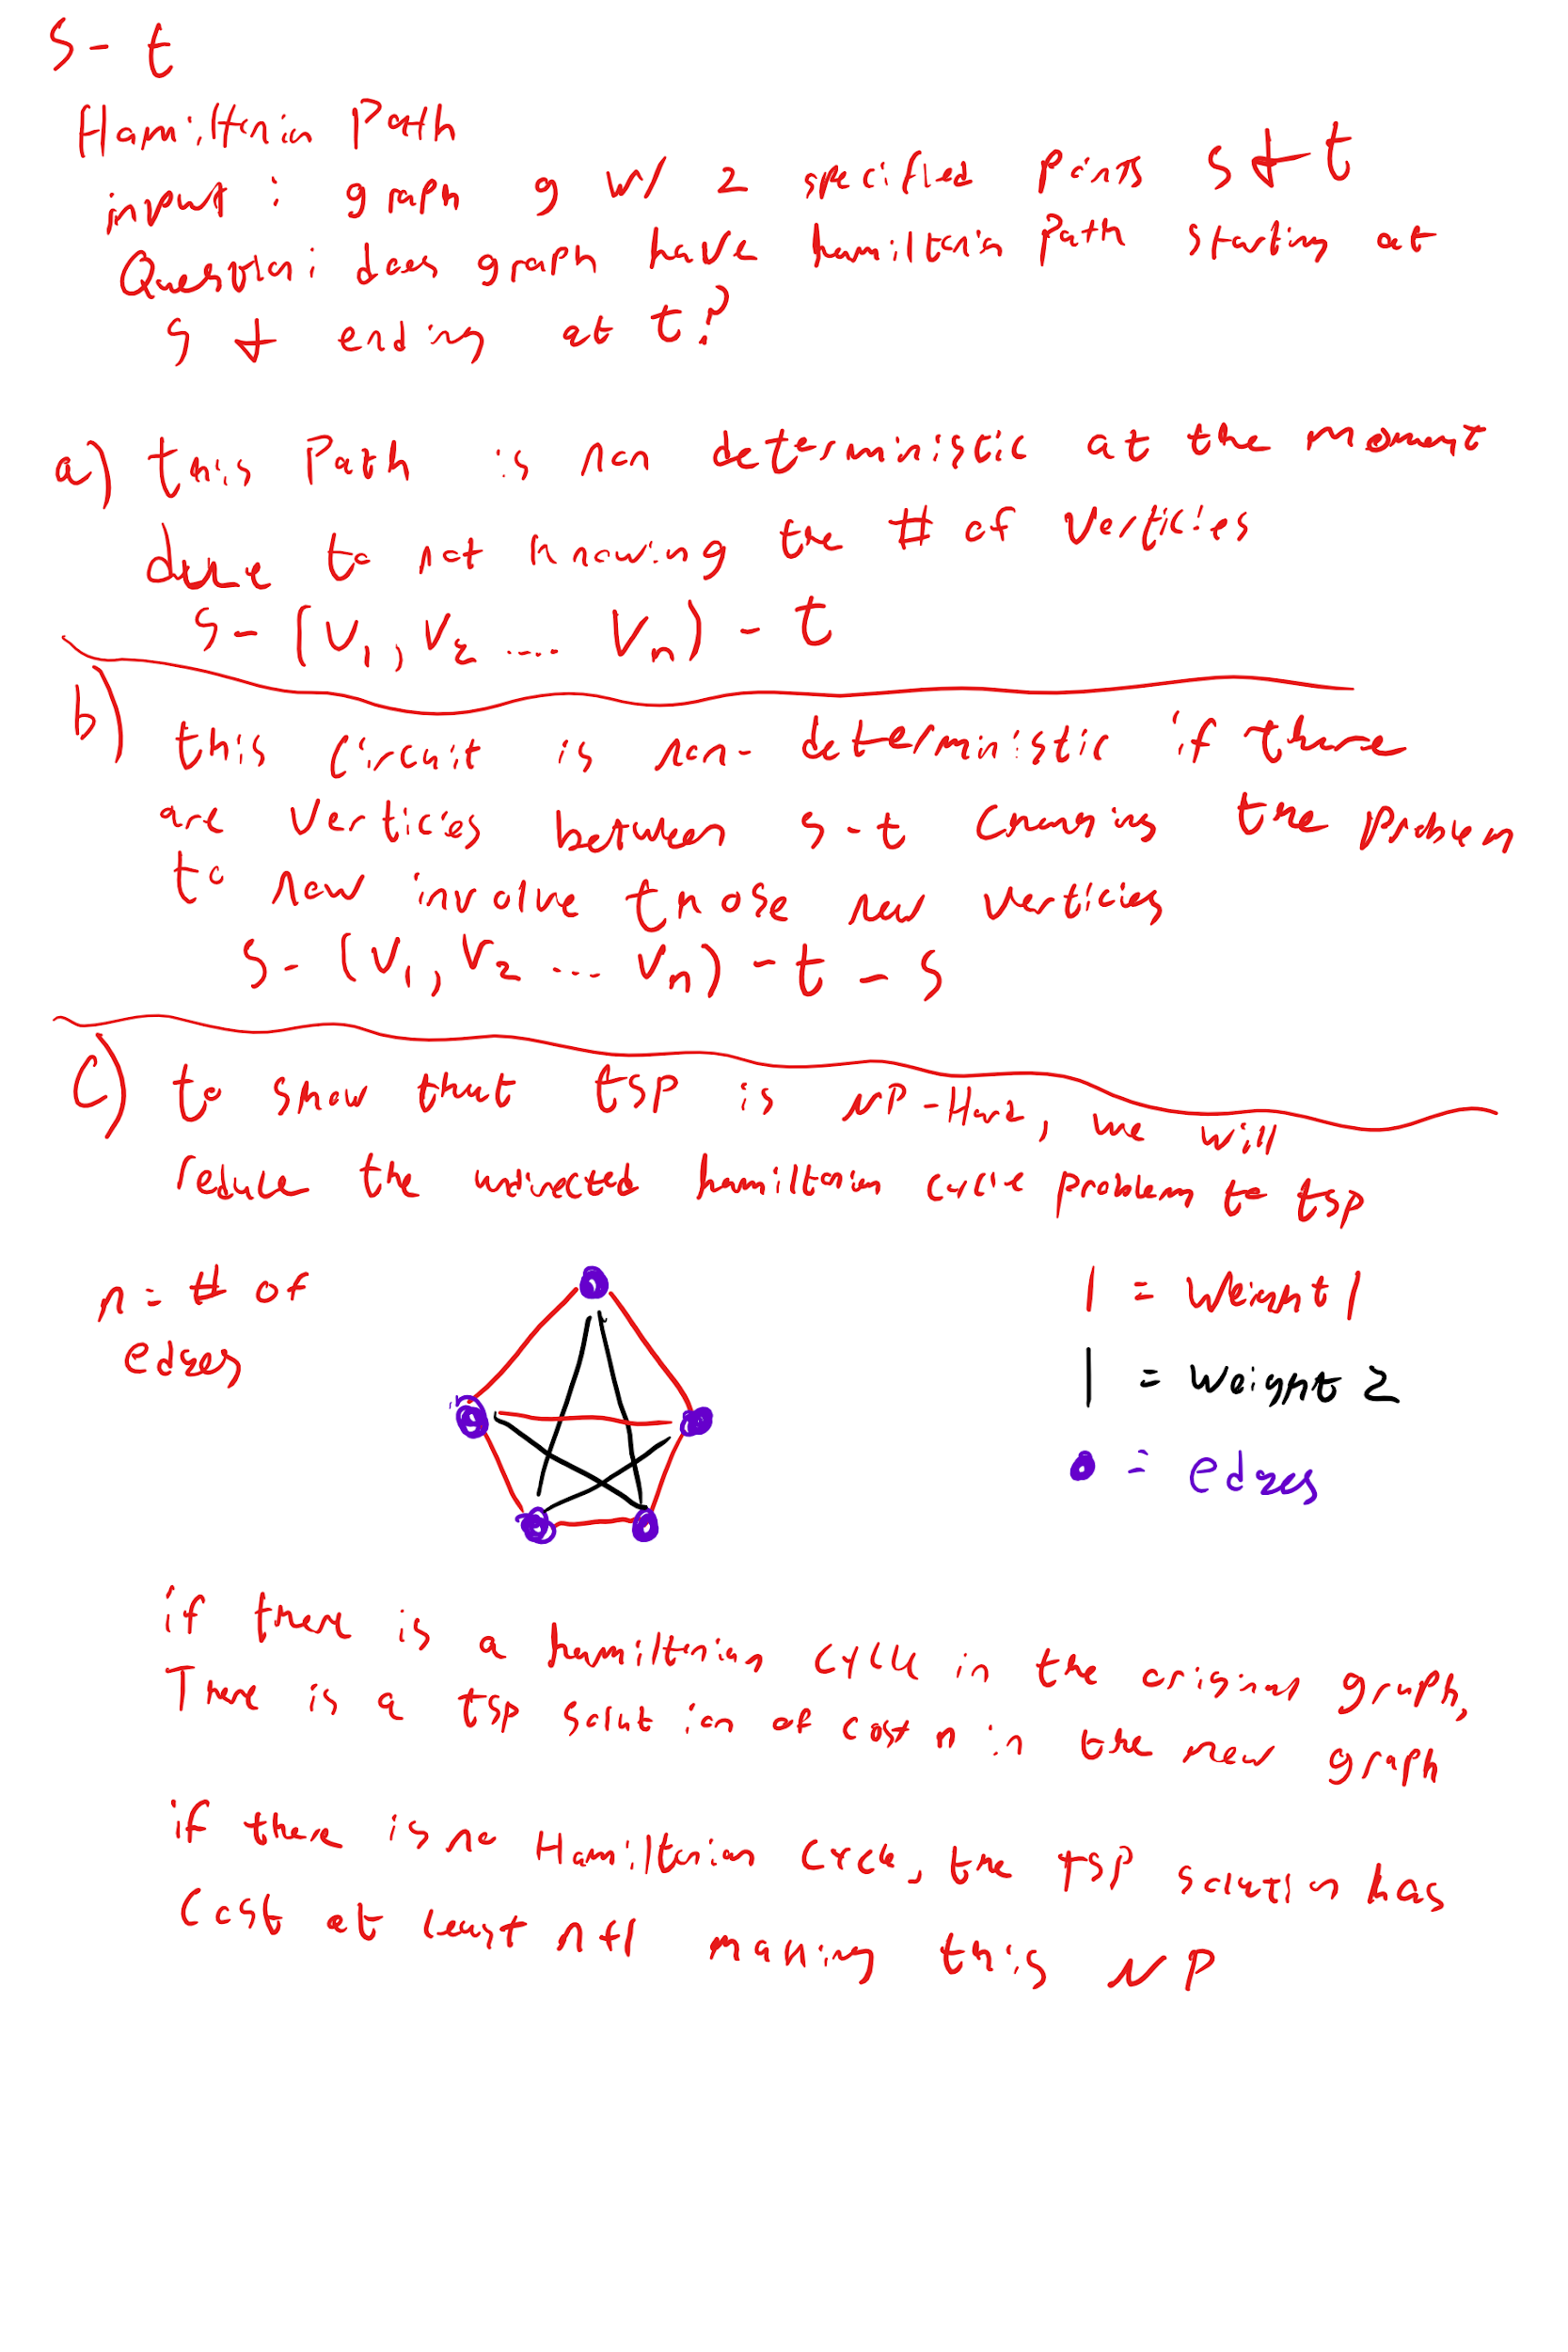

9)**Graph Isomorphism**

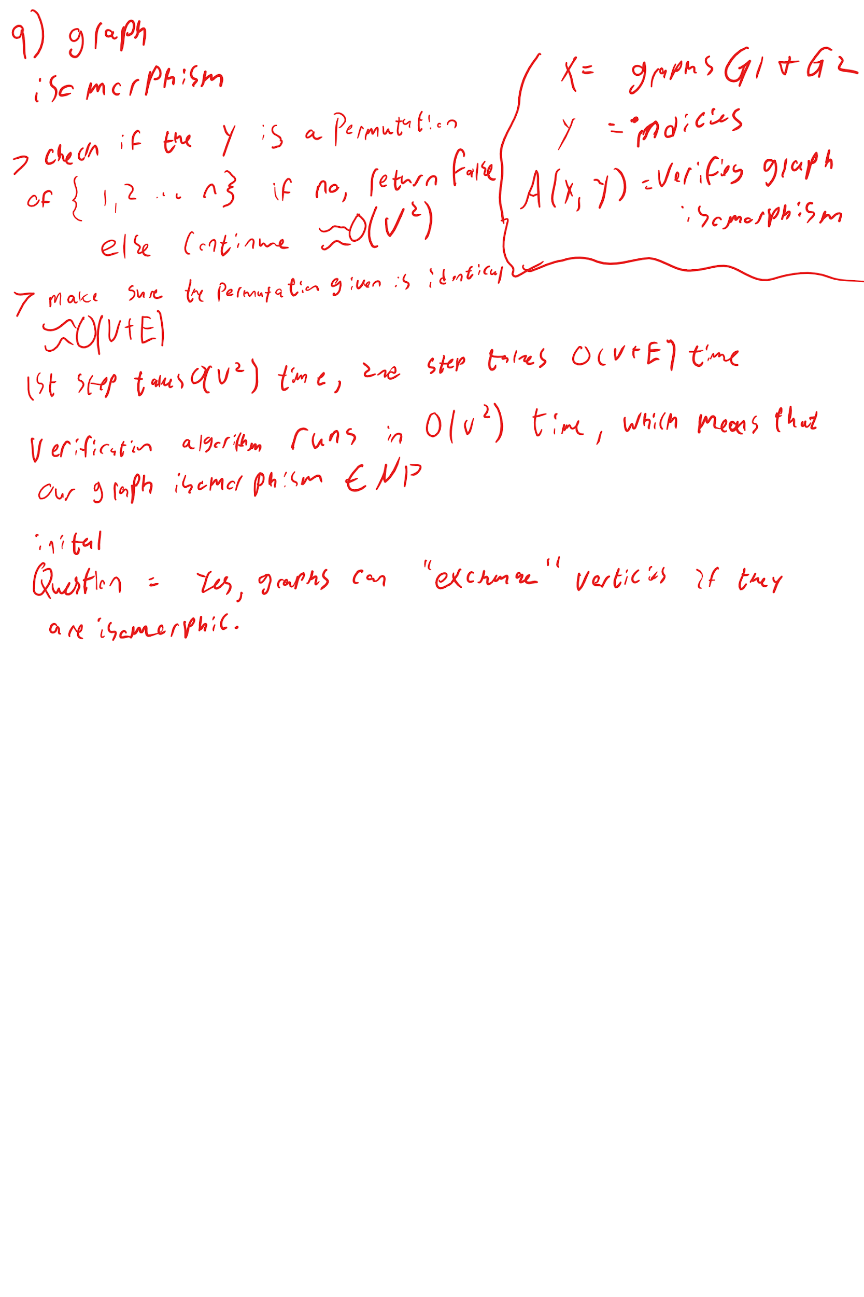

10)**Canonical Number**

**n/a**

11)**Tautology**

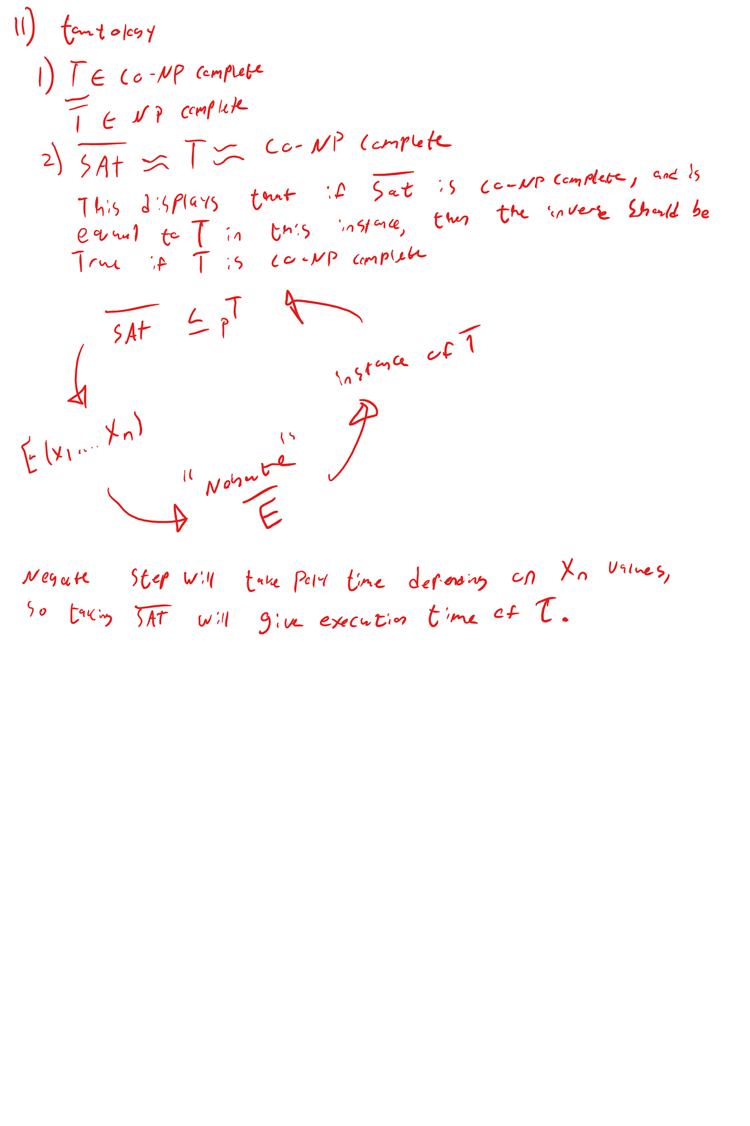

12)**3-SAT**

